To all NGJA Members,
It is time to register for the 2025 NCAA Judges Challenge!!! This year, the team registration and scoring system have been put into an app to simplify the process for everyone involved. You will register, set up your team, enter your scores and see your results all in the same app.
In addition, your team members can access the site at any time as well and track your progress. Below is the link to the registration and team set up page. Paste this link into your URL and you will be taken to the page below.
https://ncaachallenge.xojocloud.net/
Please do not use Microsoft Internet Explorer or Microsoft Edge. Use Chrome, Safari, or Firefox.
Simply follow the instructions below to register and enter your team name, members and set up your password.
Instructions:
1. Enter the Link above into your URL and you will arrive at the page below
2. Click on the "Log In" button below the password box - DO NOT enter a username and password to start
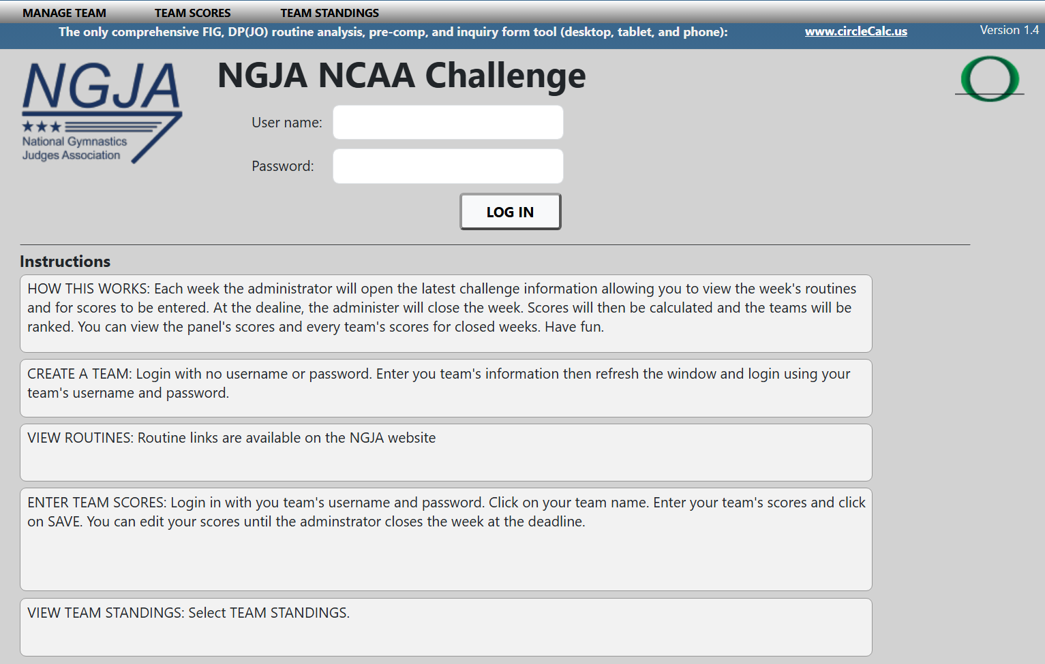
3. You will arrive at the "Add Team" page below
4. Enter your Team Name
5. Enter a Username for the Team (team members must use this)
6. Enter a Password for the Team (team members must use this)
7. Enter each team member’s name, email address, and state. Select one team member as the main contact
8. Click on the SAVE button!!!! Your team is saved but you are not logged in.
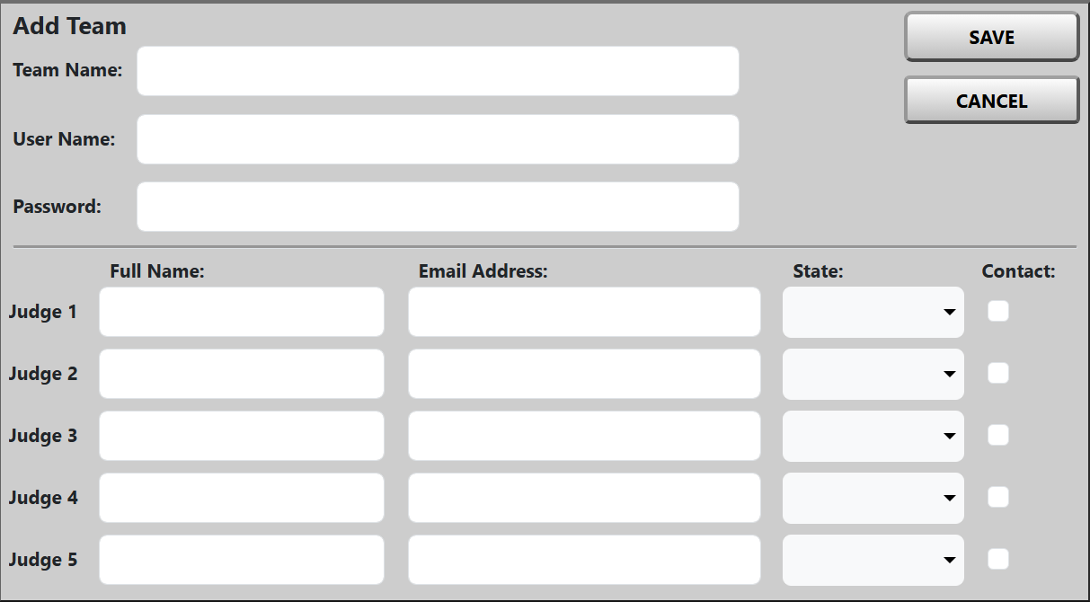
9. Refresh your current internet page and you will return to the home page below - same as where you started
10. Enter your Team Username
11. Enter your Team Password
12. Click on the "Log In" button
13. You will go to the Enter Team Scores page. Your team should be listed on the left.
Congratulations, your team is registered and you are ready for Week 1.
If you have problems with any of the steps above, contact John Scanlan at jvscanlan@myctl.net

